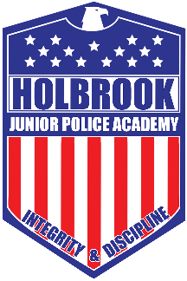
Holbrook Police Junior Police Application
- Registration is first come, first serve for 5th and 6th graders.
Applicant
Name: ______________________________________ D.O.B: ____/____/______ Age: _______
Address: ______________________________________________________________________
Parent/Guardian
Mother’s name: ________________________________________________________________
Address: ______________________________________________________________________
Telephone number: __________________________ Cell: _______________________________
Father’s Name: _________________________________________________________________
Address: ______________________________________________________________________
Telephone number: __________________________ Cell: _______________________________
Emergency Contact:
Name: ________________________________________________________________________
Address: ______________________________________________________________________
Telephone number: __________________________ Cell: _______________________________
Relationship: __________________________________________________________________

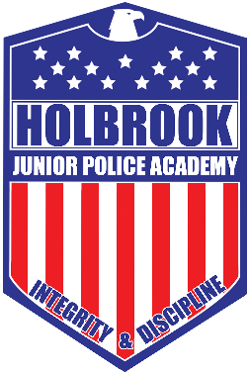

Town of Holbrook Police Department Parental Consent and Release form
I, ____________________________parent or guardian of ______________________________,
do hereby consent to his/her participation in the voluntary Junior Police Academy sponsored by the Holbrook Police Department. The undersigned hereby agrees that I will assume any and all risks resulting from the attendance and participation of my child at such functions and activities of the Junior Police Academy. I further release the town of Holbrook and the Holbrook Police Department from any and all liability resulting in my minor child’s attendance and participation.
I further agree to indemnify and hold harmless the town of Holbrook, its agents, employees, officers, directors, and volunteers from any and all claims, demands, expenses, and liability, whether for personal injury, death, or property damage arising out of the participation of my minor child in a Junior Police Academy function or activity.
I further consent and authorize the town of Holbrook to make use of my minor child’s name, pictures, photographs, and other likeness of the child in newspapers, advertisements or on the town of Holbrook Police Department website to further promote the program.
Signature of Parent/Guardian: ___________________________________________________
Date: ____________________________

